WEDE5020 – Web Development (Introduction)
Website Project Proposals
Task 2.1: Two Website Project Proposals
Student Name: [Your Full Name]
Student Number: [Your Student Number]
Group: [Your Group, if applicable]
Date: 31 July 2026

Table of Contents

Website Project Proposal 1: SWANKER (Retail Store)

1. Organisation Overview
SWANKER is a Johannesburg-based streetwear and sneaker retailer that began in 2019 as a weekend pop-up stall at local markets before opening its first physical store in 2021. The brand built its reputation on curated sneaker drops, limited-edition apparel, and close ties to local hip-hop and skate culture.
Mission: to make premium streetwear and sneaker culture accessible to young South Africans through authentic product curation and community-driven experiences.
Vision: to become the go-to destination for streetwear in Gauteng, both in-store and online.
Target audience: fashion-conscious 16–30 year olds, primarily students and young professionals who are highly active on Instagram and TikTok.

2. Website Goals and Objectives
The website's primary goal is to convert SWANKER's loyal social media following into paying online customers, extend reach beyond Johannesburg, and build an email list for future drop announcements.
- KPI: Monthly online sales revenue
- KPI: Website conversion rate
- KPI: Average order value
- KPI: Email newsletter sign-up rate

3. Current Website Analysis
SWANKER currently has no website and relies solely on an Instagram page for sales enquiries. Its strength is a highly engaged following of roughly 15,000 Instagram followers. Its weaknesses are the lack of a searchable product catalogue, no secure checkout, and lost sales when stock updates get buried in the social media feed. These weaknesses point directly to the need for a dedicated e-commerce site with a proper product catalogue and checkout.

4. Proposed Website Features and Functionality
- Homepage featuring current and upcoming drops
- Shop page, filterable by size, brand, and category
- Individual product pages with size guides
- About Us and Contact/Store Locator pages
- Secure cart and checkout
- Countdown feature to build hype ahead of limited releases

5. Design and User Experience
Colour Scheme: black, white, and gold, reflecting a premium streetwear identity.
Typography: bold, modern sans-serif (Montserrat) for headings, paired with a clean Open Sans for body copy.
Layout and Design: a mobile-first, grid-based product showcase with generous product imagery, since ample product photography is a key driver of online shopper trust (K-eCommerce, 2023).
User Experience: a sticky navigation bar, on-site search, and a streamlined single-page checkout to reduce cart abandonment (Shopify, 2026). Low-fidelity wireframes below visualise the homepage and shop page layout and information hierarchy ahead of development.
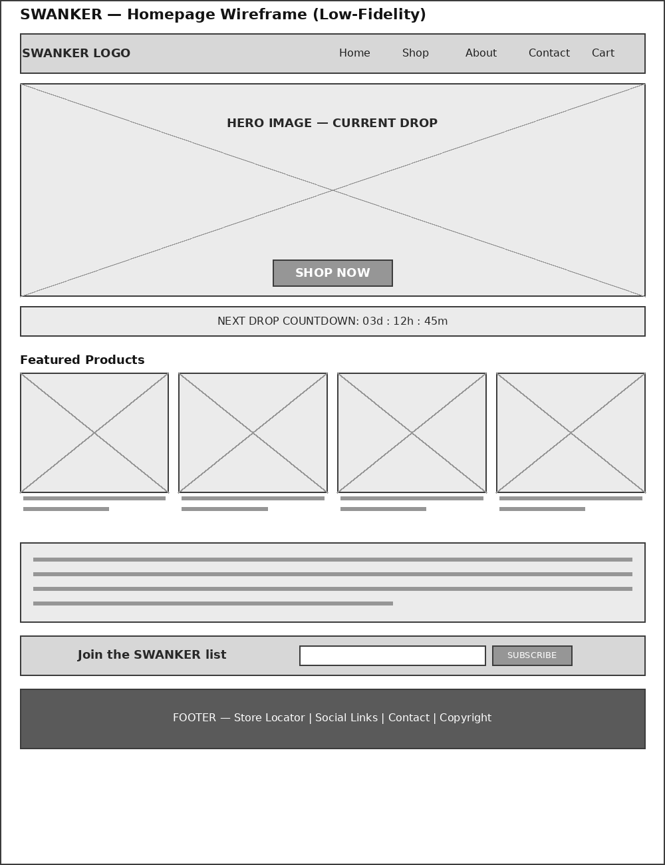
Figure 1: SWANKER homepage wireframe
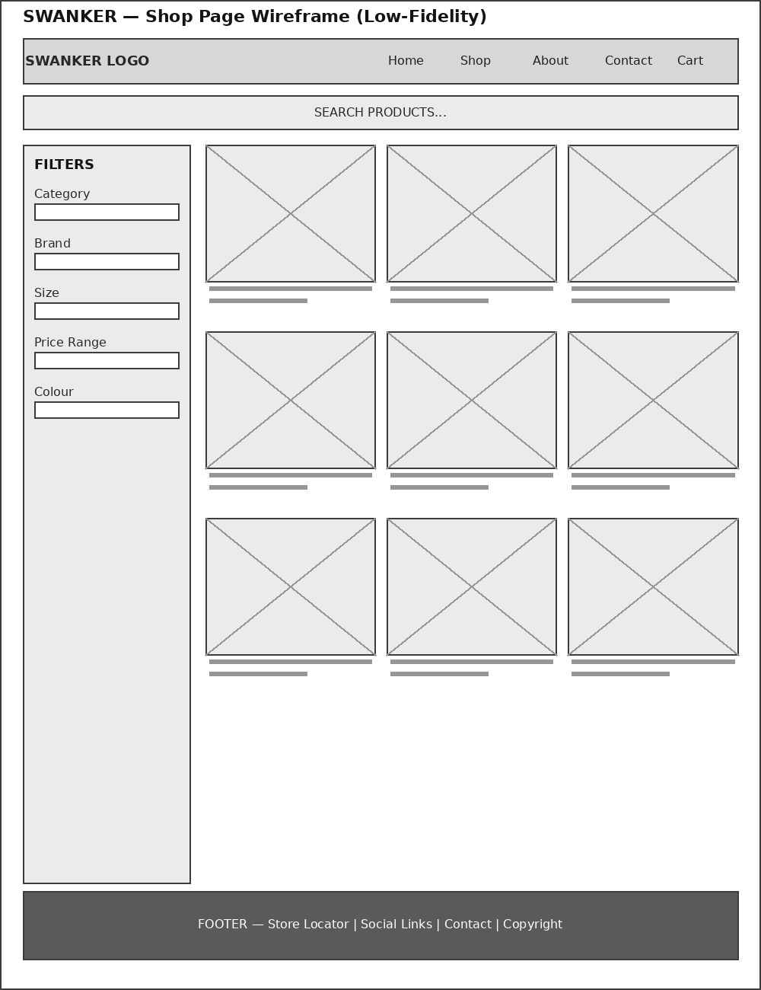
Figure 2: SWANKER shop page wireframe

6. Technical Requirements
Domain: swanker.co.za. Hosting: a South African shared hosting package with e-commerce support. Development stack: HTML5, CSS3, and JavaScript, layered with a WooCommerce plugin for product listings and payment processing.

7. Timeline and Milestones
Milestone | Weeks | Key Deliverable
Wireframing & content gathering | 1–2 | Approved wireframes and product content
HTML structure | 3–4 | Static page structure for all core pages
Styling & responsiveness | 5–6 | Fully styled, mobile-responsive pages
E-commerce integration & testing | 7–8 | Live cart/checkout, tested and launched

8. Budget
Item | Estimated Cost (ZAR)
Domain registration (swanker.co.za) | R120 / year
Shared hosting with e-commerce support | R150 / month (R1,800 / year)
WooCommerce setup & payment gateway fees | R1,500 once-off
Product photography | R2,000
Estimated first-year total | R5,400 – R6,500

9. References
- K-eCommerce (2023) 7 Ecommerce UX Best Practices for B2B Businesses in 2023. Available at: https://k-ecommerce.com/blog/ux-ecommerce-best-practices (Accessed: 31 July 2026).
- Shopify (2026) Ecommerce UX: Design Strategies and Best Practices. Available at: https://www.shopify.com/blog/ecommerce-ux (Accessed: 31 July 2026).
- RegisterDomain.co.za (2025) Cost of Domain Registration and Hosting in South Africa. Available at: https://www.registerdomain.co.za/blog/domain-hosting-costs-south-africa/ (Accessed: 31 July 2026).
- CJX Studios (2026) Website Registration Cost in South Africa. Available at: https://cjxstudio.co.za/website-registration-cost-south-africa-2026.html (Accessed: 31 July 2026).

Website Project Proposal 2: Siya's Chillers (Restaurant)

1. Organisation Overview
Siya's Chillers is a family-run braai and grill restaurant that has served the Soweto community since 2015. What began as a weekend braai stand outside the family home grew into a sit-down eatery known for its slow-grilled meats, laid-back "chill spot" atmosphere, and weekend live music.
Mission: to serve honest, affordable South African comfort food in a welcoming space where the community can gather.
Vision: to become Soweto's favourite neighbourhood chill spot while growing a loyal online following.
Target audience: local families, young professionals, and students seeking affordable, social dining.

2. Website Goals and Objectives
The website should let customers view the menu, book a table, and place takeaway orders online without needing to phone in during busy service.
- KPI: Number of online reservations per month
- KPI: Online (takeaway) order volume
- KPI: Bounce rate on the menu page

3. Current Website Analysis
Siya's Chillers currently relies on a Facebook page for updates and phone calls for bookings. Its strength is a strong local word-of-mouth reputation and an active Facebook following. Its weaknesses are the absence of a searchable online menu, no booking system, and missed reservations during peak hours when phone lines are busy. Most diners now expect to book online rather than call in, making an online reservation form a clear priority (TouchBistro, 2023).

4. Proposed Website Features and Functionality
- Homepage with hero image, opening hours, and location
- HTML-based, mobile-readable menu (not a PDF)
- Photo gallery of the venue and dishes
- About Us page
- Reservations/Contact page with an embedded booking form and click-to-call button

5. Design and User Experience
Colour Scheme: warm terracotta, cream, and deep green, evoking a braai and shisanyama atmosphere.
Typography: Poppins for headings and Lato for body text, for a friendly, easily readable feel.
Layout and Design: a photo-led homepage that immediately communicates the "chill spot" vibe.
User Experience: keeping the reservation button visible on every page and the menu just one tap away, since accessible menus and prominent booking calls-to-action directly increase reservations (TouchBistro, 2023). Low-fidelity wireframes below map the homepage and the menu/booking journey ahead of development.
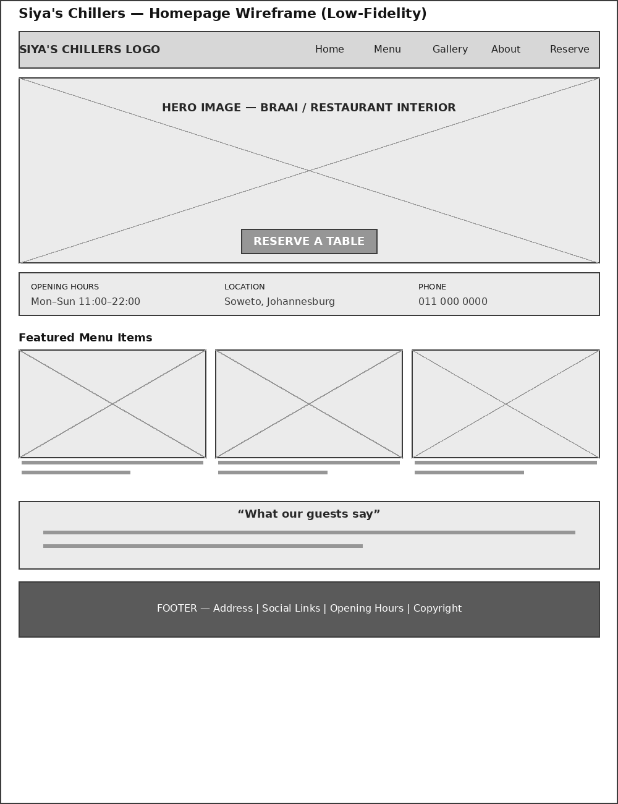
Figure 3: Siya's Chillers homepage wireframe
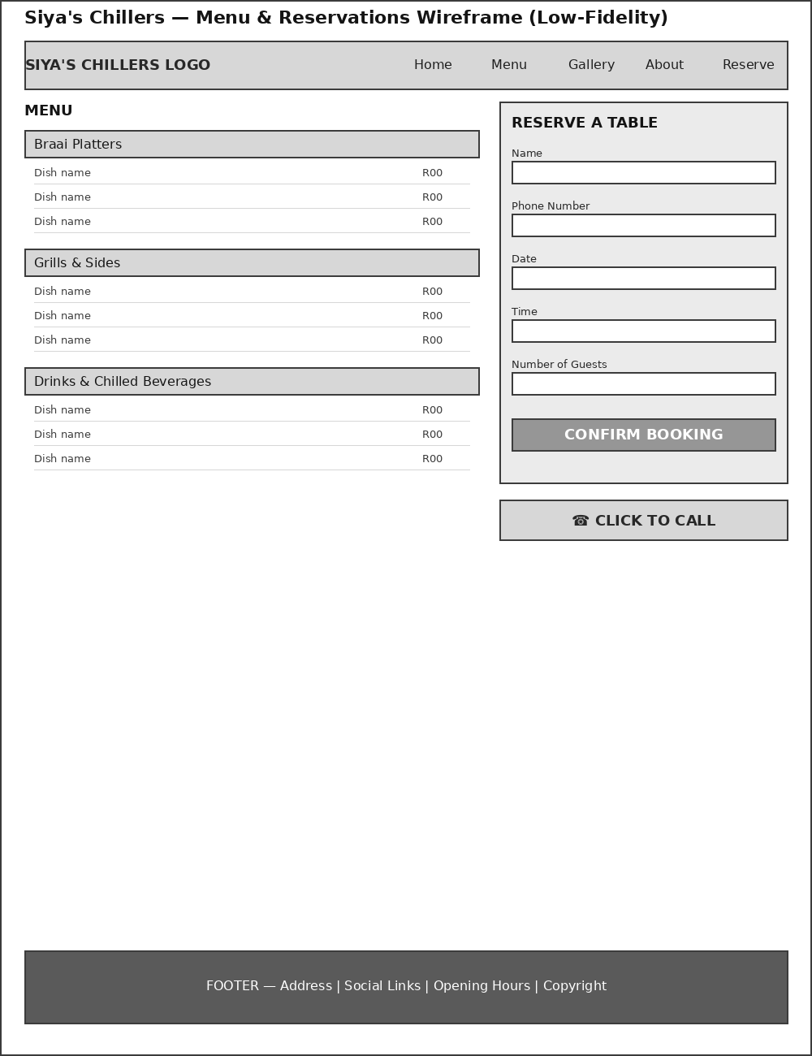
Figure 4: Siya's Chillers menu & reservations wireframe

6. Technical Requirements
Domain: siyaschillers.co.za. Hosting: local South African shared hosting for fast in-country load times. Development stack: HTML5, CSS3, and JavaScript, with an embedded booking widget (or Google Forms) for reservations.

7. Timeline and Milestones
Milestone | Weeks | Key Deliverable
Wireframing & menu content collection | 1–2 | Approved wireframes and final menu copy
HTML structure | 3–4 | Static page structure for all core pages
Styling & photography integration | 5–6 | Fully styled, responsive pages with gallery
Booking integration, testing & launch | 7–8 | Live booking form, tested and launched

8. Budget
Item | Estimated Cost (ZAR)
Domain registration (siyaschillers.co.za) | R120 / year
Local shared hosting | R120 / month (R1,440 / year)
Food & venue photography | R1,800
Booking widget integration | R500 once-off
Estimated first-year total | R3,860 – R4,500

9. References
- TouchBistro (2023) Online Restaurant Reservations: How to Optimize Your Website. Available at: https://www.touchbistro.com/blog/online-restaurant-reservations/ (Accessed: 31 July 2026).
- Network Solutions (2026) Restaurant Website Design Guide for Owners. Available at: https://www.networksolutions.com/blog/best-restaurant-website-designs/ (Accessed: 31 July 2026).
- RegisterDomain.co.za (2025) Cost of Domain Registration and Hosting in South Africa. Available at: https://www.registerdomain.co.za/blog/domain-hosting-costs-south-africa/ (Accessed: 31 July 2026).
- Truehost (2025) How Much Does a Domain Cost in South Africa? Available at: https://truehost.co.za/cost-of-domain-name-south-africa/ (Accessed: 31 July 2026).

